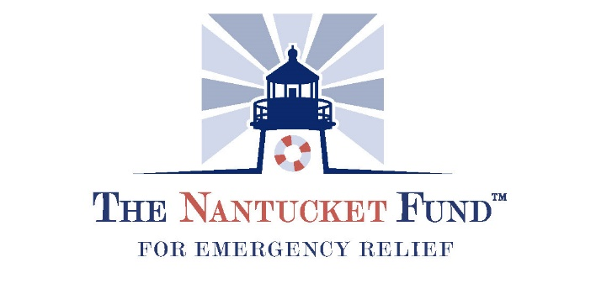
Food Initiative Program
Nonprofits MUST receive authorization from the Community Foundation prior to engaging in a partnership with a restaurant. Please reach out to Jeanne Miller or Carlisle Jensen to learn more about this opportunity.

Copies of invoices or receipts and The Community Engagement Reimbursement Form must be submitted to Diana Harrison dharrison@cfnan.org. Any questions please call 508-825-9993

Organization Name (Must be a 501(c)(3) or Town of Nantucket affiliate or religious organization):

EIN Number:

Address:

City: State: Zip:

Contact: Phone:

Email:

Number of meals ordered :

Restaurant engaged :

Amount requested for reimbursement:

