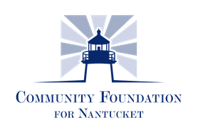

Community Health Initiative
Healthy Nantucket 2020
2019 GRANT APPLICATION
CONTACT INFORMATION:
Organization/Applicant Name: __________________________________________________________
Address:______________________________________________________________________
City:____________________________ State:______ Zip:________
Phone:__________________________
Email:__________________________ Website:______________________________________
Project contact/Title:____________________________________________________________
Direct Phone:_______________ Direct Email:____________________________
Executive Director :_________________________________________________________
Direct Phone:________________ Direct Email:____________________________
Number full time equivalent employees ______
Number of board meetings per year ___ Number of board members who contribute to annual budget __

PROGRAM INFORMATION: 501(c)(3)? Y □ N □ Other ____________________________
Which of the Community Identified Sector does your request address:

Access to Affordable Housing
Access to Healthcare
Access to Women and Children Health
Behavioral Health
Other (explain how it relates to the Community Needs)

      - Please describe your organization and the program/services you provide in detail. You should be as concise as possible, but please feel free to add additional lines if necessary.

      - Date Founded/Mission Statement/Business Case.

      - Describe which Sector, Goal, Objective, and Strategy your request will address? (Example: This grant request addresses 4.1.4.).

      - Describe the proposed program.

      - Please include the target population and number of people on Nantucket who will be directly served by this program/project. What would be the frequency/duration of this program?

      - Who are the key staff and/or volunteers directly involved in this program? Is this a new initiative or currently operating program?

      - What is the total cost of the program/project? How was this cost estimate determined? What percent of this amount, if any, will be directed to the evaluation of the program/project?

      - What is the amount of the grant you are requesting from the Community Health Initiative/Healthy Nantucket 2020?

      - Is there any other additional funding available for this program/project? If so, please identify sources and amounts. (fund raising events, annual appeal, other grants, etc.) and what % of this project are you requesting from Community Health Initiative/Healthy Nantucket 2020?

      - If this program is not fully funded will this program be implemented?

      - When do you plan to initiate this program and when will it be completed?

      - What is your baseline for measurements of your initiative? And what milestones do you expect to reach semi-annually? And annually?

      - Will any other organizations be participating in the proposed program? If so, which organization.

      - What infrastructure do you have in place to support the program/project (i.e. staffing, facilities, equipment)?

      - How will you know your program/project had an impact on the Nantucket community?

      - What documented evidence will you use in your evaluation, and or how will you define success for your program?

      - If your initiative will take more than one year, how many of the 5 years do you anticipate applying?

      - Outline your plan for sustaining this program/project beyond its initial inception [without further grant money].

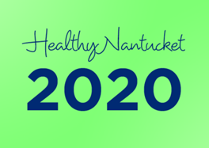
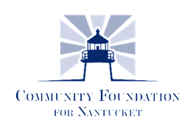

Grant Application Acknowledgement Form
Community Health Initiative/ Healthy Nantucket 2020 will award grants only to organizations that have met all requirements in their application.
A member of the Staff and/or Sector team member will follow up with all Grant applicants.
If at any point in the application process the applicant experiences difficulty, we encourage you to consult with the Program Officer to seek solutions. There will be reviews throughout the grant process by members of the Community Health Initiative . We offer support throughout the process so don’t hesitate to reach out to the Community Foundation for Nantucket.
Each recipient receiving a grant must meet requirements of reporting and accountability of all financial expenditures
We have read the Grant Guidelines and acknowledge that I understand that receipt of this application does not imply eligibility or approval and that all of the information contained in the application is current and accurate to the best of my knowledge.
Executive Director Signature

Date

Board of Trustee Rep.

Organization

The Community Foundation for Nantucket
PO Box 204, Nantucket, MA 02554 - 508-825-9993 - Jmiller@cfnan.org

