Community Engagement Initiative

Non-Profit Reimbursement Form

Copies of invoices or receipts for the room rental and The Community Engagement Reimbursement Form must be submitted to Diana Harrison dharrison@cfnan.org. Any questions please call 508-825-9993

Organization Name (Must be a 501(c)(3) or Town of Nantucket affiliate or religious organization):

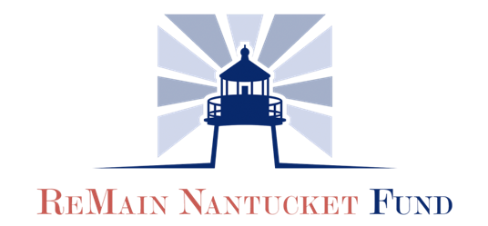

EIN Number:

Address:

City: State: Zip:

Meeting Contact: Phone:

Email:

Meeting Date:

Meeting Purpose:

Meeting Location:

Amount requested for reimbursement (limited to $250):

Location Contact Name:

