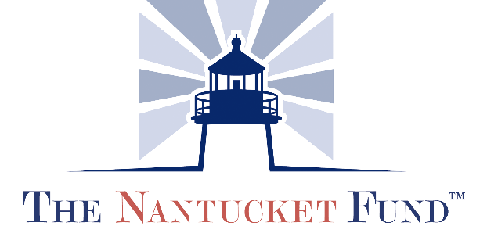

Grant Application
Date: ______________________

Organization Name:

Address:

City: State: Zip:

Phone:

Email:

Project contact/Title:

Direct Phone: Direct Email:

Executive Director:

Direct Phone: Direct Email:

Board Chair Name: Direct Email:

Number full time equivalent employees
Number of board members (Attach a list of member names)
Number of board meetings per year
Number (or %) of board members who contribute to annual budget

ORGANIZATION INFORMATION:
Date Founded/Mission Statement:

What percent of your budget comes from fundraising events?

What percent of your budget comes from grants?

APPLICATION INSTRUCTIONS:

When completing your application, please describe your organization and the program/services you provide in detail. You should be as concise as possible, but please feel free to add additional lines if necessary.

- Describe the proposed program/project for which you are applying for assistance.

- Please include the target population and number of people on Nantucket who will be directly served by this program/project.

- What is the frequency/duration of this program?

- Who are the key staff and/or volunteers directly involved in this program?

- What infrastructure do you have in place to support the program/project (i.e. staffing, facilities, equipment)?

- What documented need/opportunity is being addressed by this program/project? How did you determine this need?

  - List the specific objectives of your program.

  - How will you evaluate the community impact of your program? Please include anticipated outcomes and how you will define success of the program/ project.

- If this is to be an ongoing program, outline your plan for sustaining the financial viability of this program/project beyond its initial inception.

- How do you plan to work collaboratively with other organizations serving this population/need/area? If you are not, please explain why.

- What is the total cost of the program/project?

- What is the amount of the grant you are requesting from the Community Foundation?

- Is there any other additional funding available for this program/project? If so, please identify sources and amounts.

Grant Application Acknowledgement Form

The Nantucket Fund will award grants only to organizations that have met all requirements in their application. A member of the Community Foundation Staff will follow up with all Grant applicants.

If at any point in the application process the applicant experiences difficulty, we encourage you to consult with Sunny Daily, Program Director, at sdaily@cfnan.org to seek solutions. The Foundation will offer support throughout the process, so don’t hesitate to reach out!

Each recipient receiving a grant must meet requirements of reporting and accountability of all financial expenditures.

We have read the eligibility and criteria for applying for a Nantucket Fund Grant and acknowledge that I understand that receipt of this application does not imply eligibility or approval and that all of the information contained in the application is current and accurate to the best of my knowledge.

Organization Name:

Executive Director:

Signature: Date:

Board of Trustee Rep

Signature: Date:

Please remember the following required documents with your completed application:

- Application
- 501(c) 3 Letter
- List of Trustees
- Financial Documents

