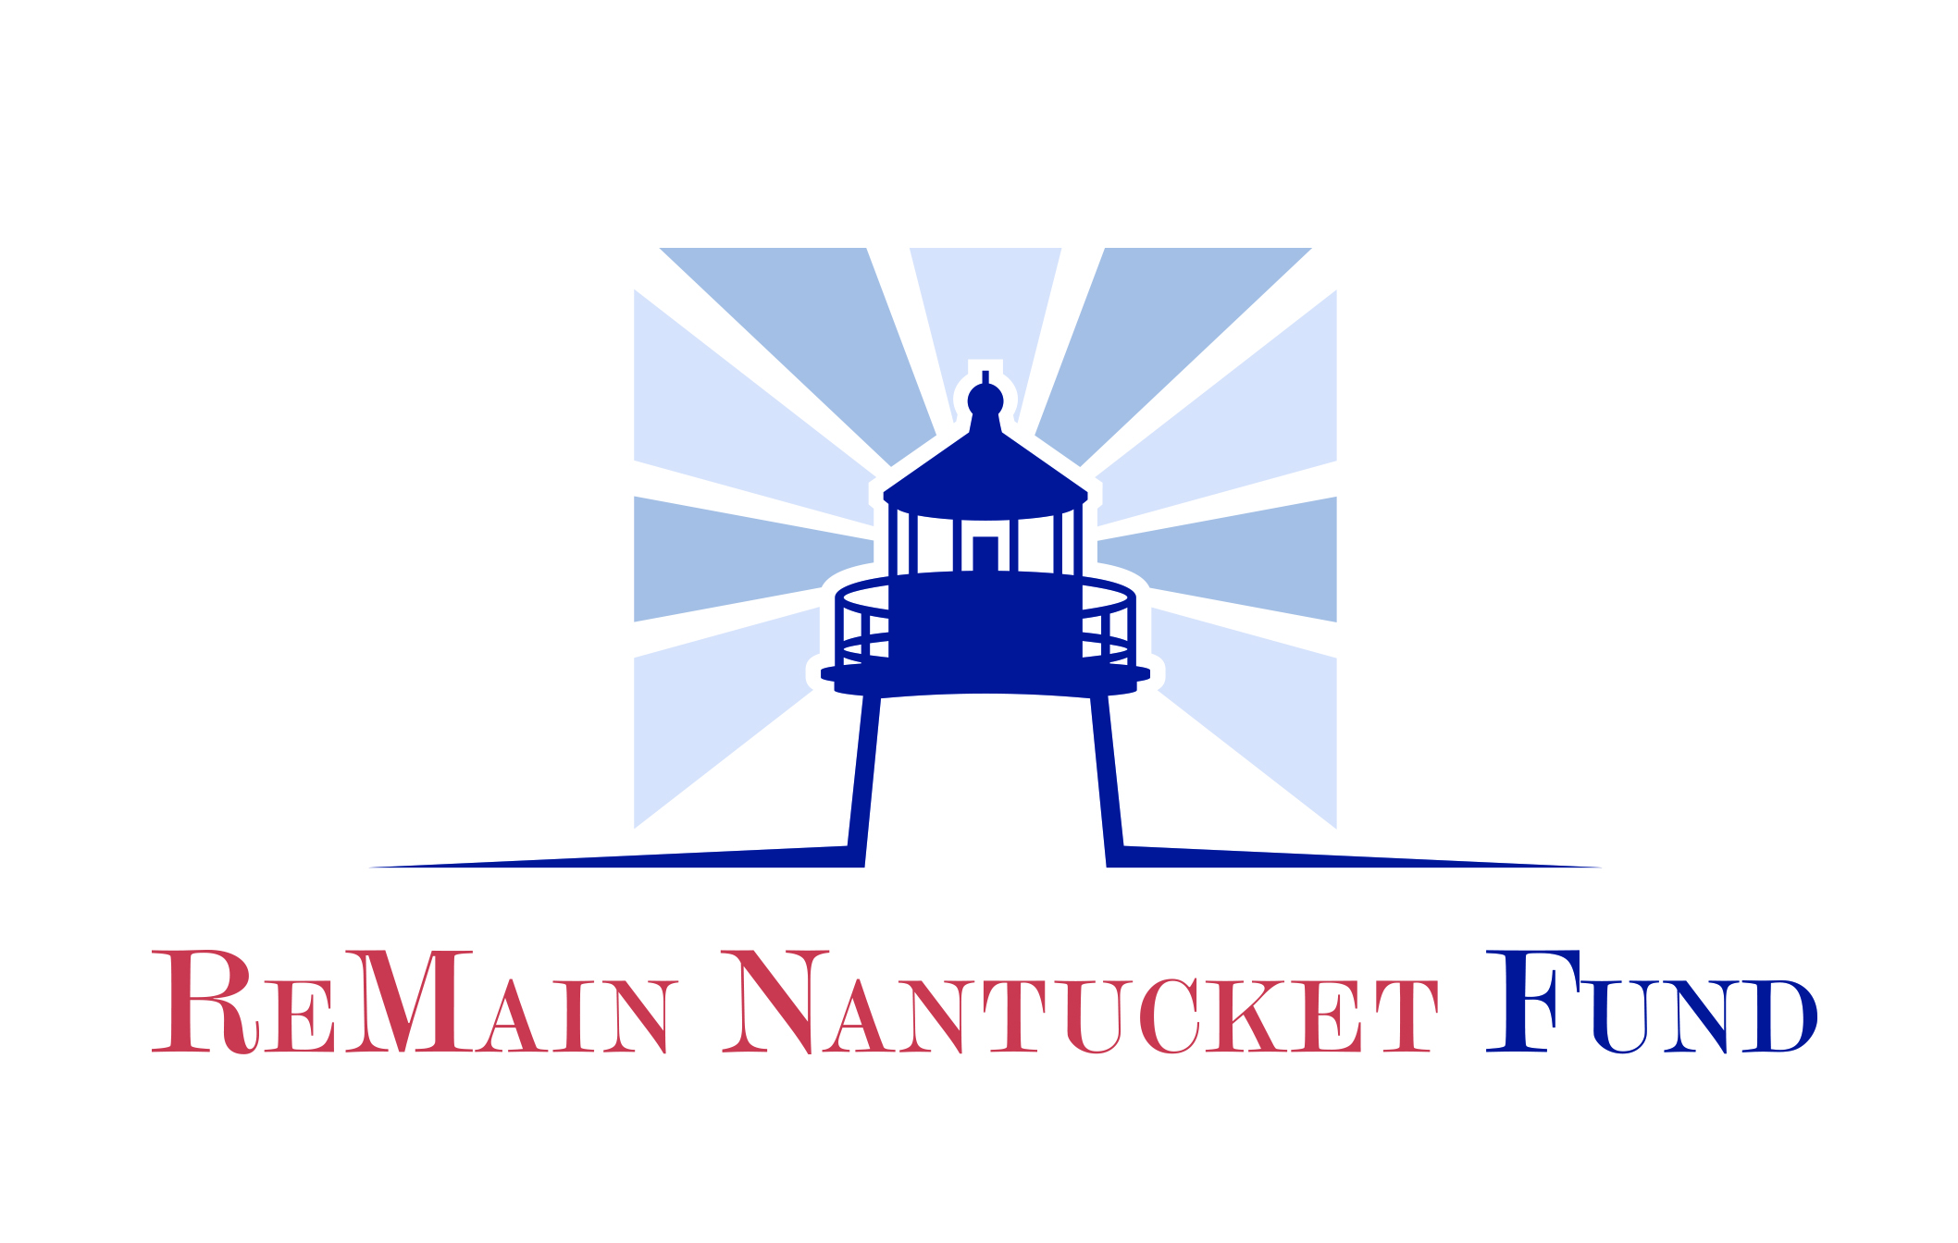

THE REMAIN NANTUCKET FUND
GRANT APPLICATION

CONTACT INFORMATION:

Organization Name: _______________________________________________________________

Address: _________________________________________________________________________

City: ____________________________ State: ______ Zip: ________

Phone: __________________________

Email: __________________________ Website: ______________________________________

Project contact/Title: ____________________________________________________________

Direct Phone: _______________ Direct Email: ____________________________

Executive Director: _________________________________________________________

Direct Phone: ________________ Direct Email: ____________________________

Board Chair Name: ______________________________ Direct Email: ________________________

Number full time equivalent employees ______ Number of board members ______ (List member names)

Number of board meetings per year ___ Number (or %) of board members who contribute to annual budget ___

PROGRAM INFORMATION: 501(c) 3? Yes___ No____
Please add IRS letter of determination as attachment with required 990s and financial statements

□ Education □ Downtown Enhancement/Culture
□ Human Services □ Scientific Research/Sustainability
□ Arts & Culture □ Conservation/Preservation

Please list all major fundraising events, the time of year they take place, and sponsorship opportunities:

Please select the category(s) that best describe your organization’s target population on Nantucket:

□ All Populations | □ Infants & Toddlers | □ Adults | Other:____________
□ Year-round | □ Children | □ Elderly
□ Seasonal | □ Adolescents/Youth | □ Disabled

THE REMAIN NANTUCKET FUND
GRANT APPLICATION

ORGANIZATION NAME: ___________________________________________________

APPLICATION INSTRUCTIONS:

When completing your application, please describe your organization and the program/services you provide in detail. You should be as concise as possible, but please feel free to add additional lines if necessary.

- Date Organization was founded/Mission Statement.

- Describe the proposed program/project for which you are applying for assistance.
Please include the description of the following:

- The target population and number of people on Nantucket who will be directly served by this program/project.

- The frequency/duration of this program?

- Key Staff and volunteers involved in this program have established or will obtain necessary expertise?

- Infrastructure in place to support the program/project (i.e. staffing, facilities, equipment)?

- What is the significance or uniqueness of this program/project? Does this project have long-lasting and/or meaningful community impact?

- Is there a demonstrated knowledge of the documented need/opportunity being addressed by this program/project? How did you determine this need?

- List the specific program/project objectives, goals, and timetable for fulfillment.

- How does this program/project meet the criteria for this fund?

- How do you plan to evaluate and determine the effectiveness of this program/project? Please include anticipated outcomes and measures you intend to use in your evaluation, or how you define measures of success for your program?

- What is the total cost of the program/project? Please list project expenses.

- What is the amount of the grant you are requesting from the ReMain Nantucket Fund?

- Is there any other additional funding available for this program/project? If so, please identify sources and amounts. Include in-kind support.

- If this is to be an ongoing program, outline your plan for sustaining the financial viability of this program/project beyond its initial inception.

The Community Foundation for Nantucket will award grants only to organizations that have met all the deadlines for project reporting, follow up and accountability for any previous grants. This can include requests for photographs, narrative information and follow up interviews.

Executive Director Signature: Date:

Designated Board Officer Signature: Date:

The Community Foundation for Nantucket
PO Box 204, Nantucket, MA 02554 - 508-825-9993 - Jmiller@cfnan.org

