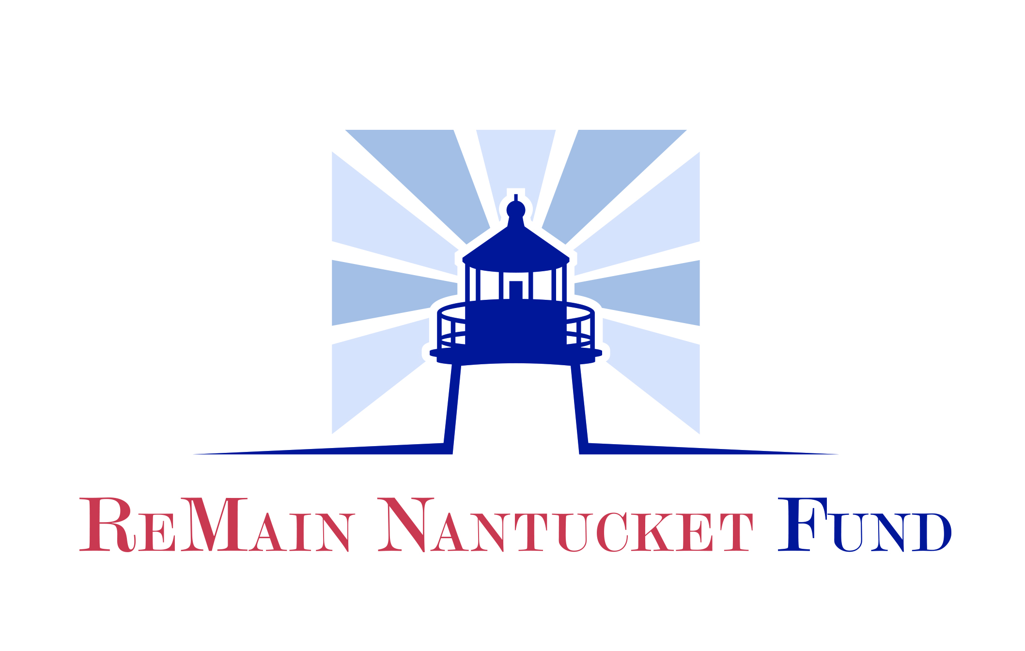

THE REMAIN NANTUCKET FUND
2019 GRANT APPLICATION
Cover Page

CONTACT INFORMATION:

Organization Name: _______________________________________________________________

Address: _________________________________________________________________________

City: ____________________________ State: ______ Zip: ________

Phone: __________________________

Email: __________________________ Website: ______________________________________

Project contact/Title: ____________________________________________________________

Direct Phone: _______________ Direct Email: ____________________________

Executive Director: _________________________________________________________

Direct Phone: ________________ Direct Email: ____________________________

Board Chair Name: ______________________________ Direct Email: ________________________

Number full time equivalent employees ______ Number of board members ______ (List member names)

Number of board meetings per year ___ Number (or %) of board members who contribute to annual budget ___

PROGRAM INFORMATION:
501(c) 3? Yes___ No____
Please add IRS letter of determination as attachment with required 990s and financial statements

Please select the category (s) that best describe your organization’s project or program:
Downtown Cultural Vitality
Cultural Activity
Cultural District Development
Educational Opportunities for Residents and Visitors
Community Building
Innovation through New Programs
Capacity Building
Environmental Stability

THE REMAIN NANTUCKET FUND
2019 GRANT APPLICATION

ORGANIZATION NAME: ___________________________________________________

APPLICATION INSTRUCTIONS:

When completing your application, please describe your organization and the program/services you provide in detail. You should be as concise as possible, but please feel free to add additional lines if necessary.

- Date Organization was founded/Mission Statement.

- Describe the proposed program/project for which you are applying for assistance.
Please include the description of the following:

- What is the frequency/duration of this program?

- Are there key staff and/or volunteers that are necessary to run this program effectively? Please describe.

- Describe the infrastructure in place to support the program/project (i.e. staffing, facilities, equipment)?

- The target population and number of people on Nantucket who will be directly served by this program/project.

- What is the significance or uniqueness of this program/project? Does this project have long-lasting and/or meaningful community impact?

- Is there a demonstrated knowledge of the documented need/opportunity being addressed by this program/project? How did you determine this need?

- List the specific timetable and process for fulfillment.

- How does this program/project meet the criteria for this fund?

- How do you plan to evaluate and determine the effectiveness of this program/project? Please include anticipated outcomes and measures you intend to use in your evaluation, or how you define measures of success for your program?

- What is the total cost of the program/project? Please list project expenses.

- What is the amount of the grant you are requesting from the ReMain Nantucket Fund?

- Is there any other additional funding available for this program/project? If so, please identify sources and amounts. Include in-kind support.

- If this is to be an ongoing program, outline your plan for sustaining the financial viability of this program/project beyond its initial inception.

Grant Application Acknowledgement Form

The ReMain Nantucket Fund will award grants only to organizations that have met all requirements in their application. A member of the Community Foundation Staff will follow up with all Grant applicants.

If at any point in the application process the applicant experiences difficulty, we encourage you to consult with the Jeanne Miller, Program Director, to seek solutions. The Foundation will offer support throughout the process, so don’t hesitate to reach out to the Community Foundation for Nantucket.

Each recipient receiving a grant must meet requirements of reporting and accountability of all financial expenditures.

We have read the eligibility and criteria for applying for a ReMain Nantucket Fund Grant and acknowledge that I understand that receipt of this application does not imply eligibility or approval and that all of the information contained in the application is current and accurate to the best of my knowledge.

Organization Name:

Executive Director:

Signature:
Date:

Board of Trustee Rep

Signature: Date:

For Office Use Only:

Application
Signatures
501(c) 3 Letter
List of Trustees
Financial Documents

