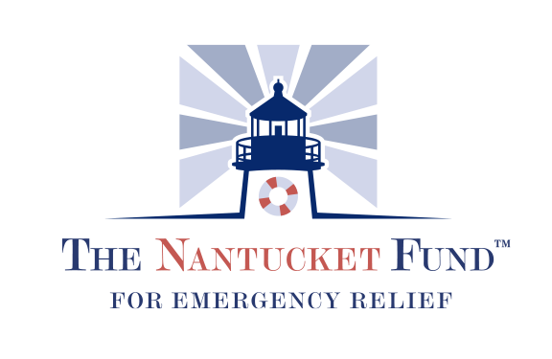
Application for Phase III Requests
Applications Due October 15, 2020 - Grants will be awarded Late-October.
Phase III: Operational requests related to loses or shortfalls due to COVID-19

- Organization Detail:
Name:
Address:
Contact:

- Total Emergency Funding Request:
(if this includes PPE and or other equipment, please include a detailed spreadsheet totaling the cost associated with your desired equipment needs)

- Has your organization been able to provide services throughout the COVID-19 Pandemic? If so, please describe.

- How has the COVID-19 Pandemic changed your revenue/ fundraising income? If your organization cancelled a fundraising event, please provide details on how you have adapted your fundraising plans.

- To properly evaluate your application, CFN needs as much detailed financial information and other supporting information as possible. This includes:
  - Data on population served. i.e. number of people assisted, meals served, assistance provided from March 1– September 30, 2019 compared to March 1 – September 30, 2020.

  - Audited financials for 2019 and a comparison of financial information from February 28 – September 30, 2019 and the same period in 2020. If that breakout for 2020 is not available, then financials from 12/31/2018 to 9/30/2019 and 12/31/2019 to 9/30/2020.

- Has your organization received any other financial support through grants, loans / federal aid? If yes, how much? If no, why not?

- Please share any scenario planning or budget forecasts that will provide specific details of your operational and liquidity needs. Please include a Latest Estimate for the year ending December 31, 2020 budget including operating revenue, expenses, net operating income and net cash flow. Please feel free to include any other additional information which you believe would be useful in supporting your grant request.

