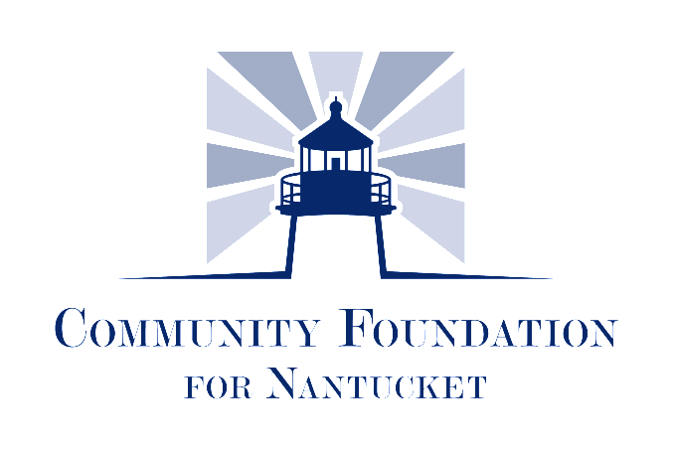

____________________
[Date]

SAMPLE DONOR ADVISED FUND

Establishing Document

Community Foundation for Nantucket
Post Office Box 204
Nantucket, MA 02554

hereby transfer cash or other property to establish the __________________________ (“Fund”) with The Community Foundation for Nantucket (“The Foundation”). We understand that this is an irrevocable gift, subject to the Foundation’s governing documents and By-Laws.

The Foundation may also receive additional contributions of cash and/or marketable securities from the Donor(s) or other individuals or businesses as well as distributions of cash and/or marketable securities from trusts, wills, private foundations or other donor advised funds to either initially fund or add to this Donor Advised Fund, subject to the terms set forth herein.

intend that the income and principal from the Fund be available for distribution in accordance with the charitable purposes set forth in the Bylaws of The Foundation. Distributions shall be made by the Foundation after receiving and approving the advice in writing from ____________ or _____________.

[If “annual net income” is chosen above, the following language should be inserted: Net income shall be defined as an amount that shall be computed annually based upon the current spending policy of the Community Foundation (currently 5% of the average past three year-end Fund balances). If any portion of the net income is not distributed in a particular calendar year, the undistributed net income for such year shall be added to principal.]

When privilege to advise the Fund terminates upon or incapacity to serve, the successor advisors to the Fund shall be _________________________ and _________________________. When or if two persons are eligible to be successor advisors, they shall act by unanimous consent; when or if more than two persons are eligible to be successor advisors, then a grant recommendation by a majority of such persons shall constitute an effective recommendation for consideration by the Foundation.
If the persons named above are not available to advise and consult with the Foundation due to death, resignation, or incapacity to serve, the Foundation shall use the principal and income from the Fund for its general and charitable purposes as set forth in the Bylaws.

Under current policy, CFN allows one generation of successive advisers for each DAF. Exceptions may be made with approval by the Foundation’s Board of Trustees. Upon the death of the last designated fund adviser, the corpus of the fund will be transferred to the Nantucket Fund, through which the Foundation awards Community Grants to Nantucket charities.

Advisers and successor advisors shall have the ability to recommend grant distributions from the of the Fund by advising the Foundation in writing. All recommendations are advisory in nature. The Foundation will independently determine if recommendations received are consistent with the Foundation’s charitable purpose. The Foundation cannot make distributions to fulfill any pledge, obligation, membership or to support any activity for which a Donor, Adviser or related party will receive more than an incidental benefit.

The Foundation maintains investment pools with varying risk and return objectives as described in the attached Investment Recommendation Form. All investment options are reviewed and approved by the Foundation’s Board of Trustees and may change from time to time as the Board determines. You may make recommendations to the Foundation for investment of your Fund in one or more of these pools. All recommendations must be in writing.

hereby acknowledge receipt of the CFN Procedures for Establishment and Operation of Funds, Administrative Fee Schedule attached and accept the terms of said schedule. further understand the fee schedule is subject to modification and may be increased or decreased at the sole discretion of the Foundation’ Board of Trustees. agree to be bound by the most current schedule of fees published by the Foundation

have received copies and accept the terms of Articles 17.01 through 18.03 of the Bylaws of the Foundation. We have read and agreed to the terms of the Foundation’s Donor-Advised Fund Grant Guidelines. also understand that the Foundation, through its duly authorized committees, reserves the right to make the final decision regarding distributions from the Fund.

Sincerely,

______________

______________

Accepted by: _________________________________________ Date:___________________________
Margaretta Andrews, Executive Director
Community Foundation for Nantucket

